Chen Liu Project

eye visual concept (cluster 51)

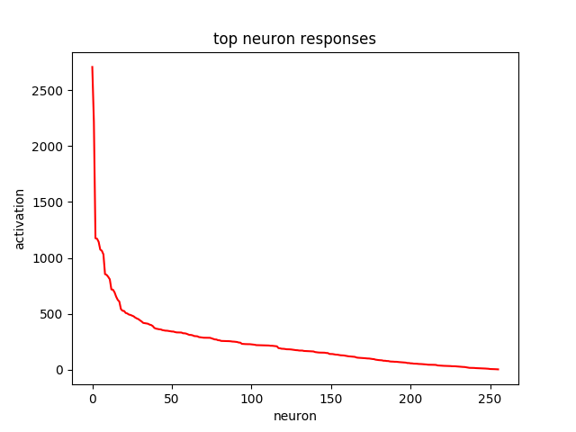

Neuron25 2707.45

Neuron 245 2216.29

Neuron 152 1175.15

Neuron 190 1171.37

use l2 normalization on activation

Neuron 25 0.28

Neuron 245 0.22

Neuron 190 0.127

Neuron 135 0.124

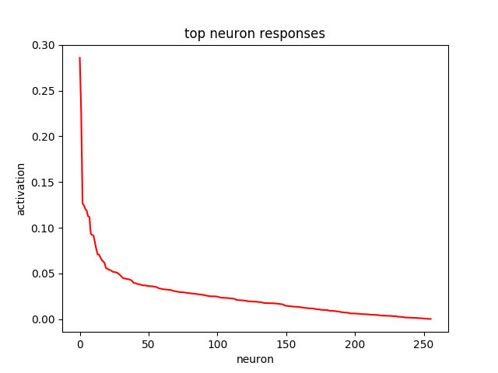

1. neuron 25: responses of about 1200000 patches (from 100 portrait images and 500 natural images)

(1) not using l2 normalization

over_half_patches:588

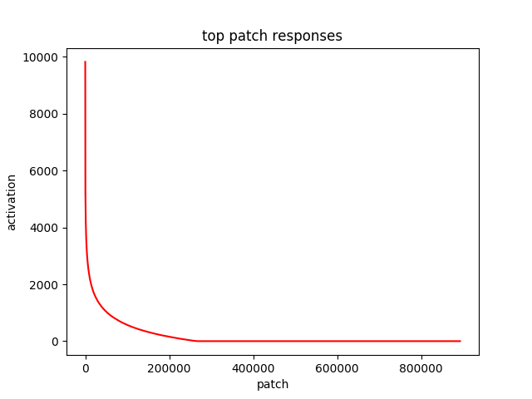

(2) using l2 normalization result

over_half_patches:7358

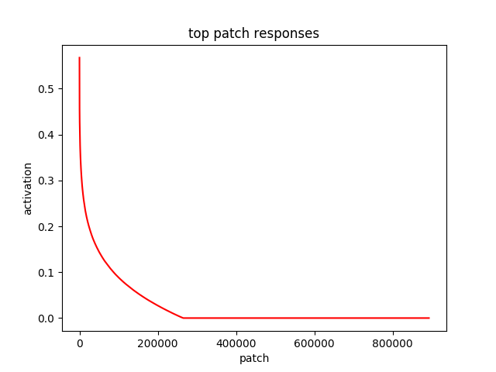

2. neuron 245: responses of about 1200000 patches (from 100 portrait images and 500 natural images)

(1) not using l2 normalization

over_half_patches:300

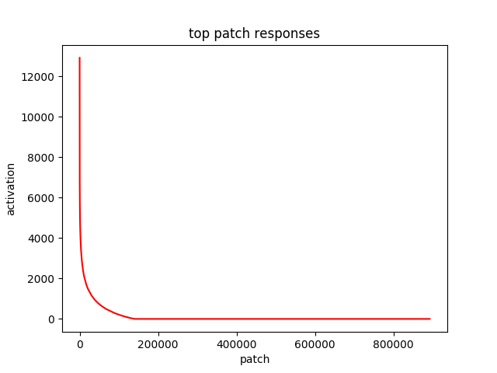

(2)using l2 normalization result

over_half_patches: 3332

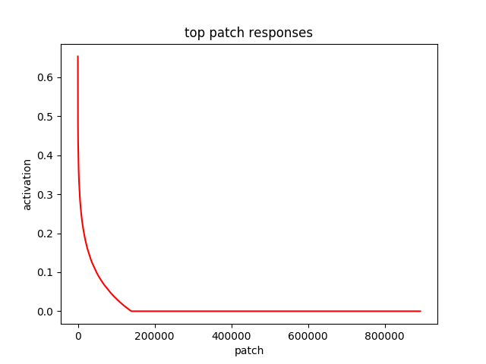

3. neuron 20: responses of about 1200000 patches (from 100 portrait images and 500 natural images)

(1) not using l2 normalization over_half_patches:188

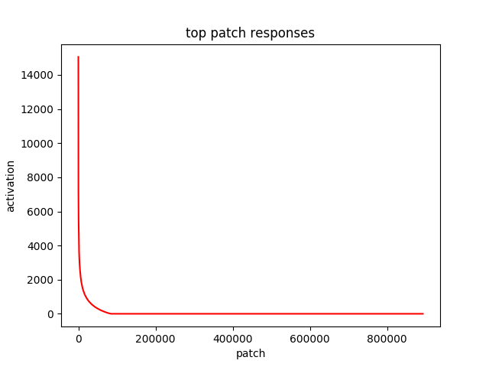(

(2)using l2 normalization result

over_half_patches:1480

